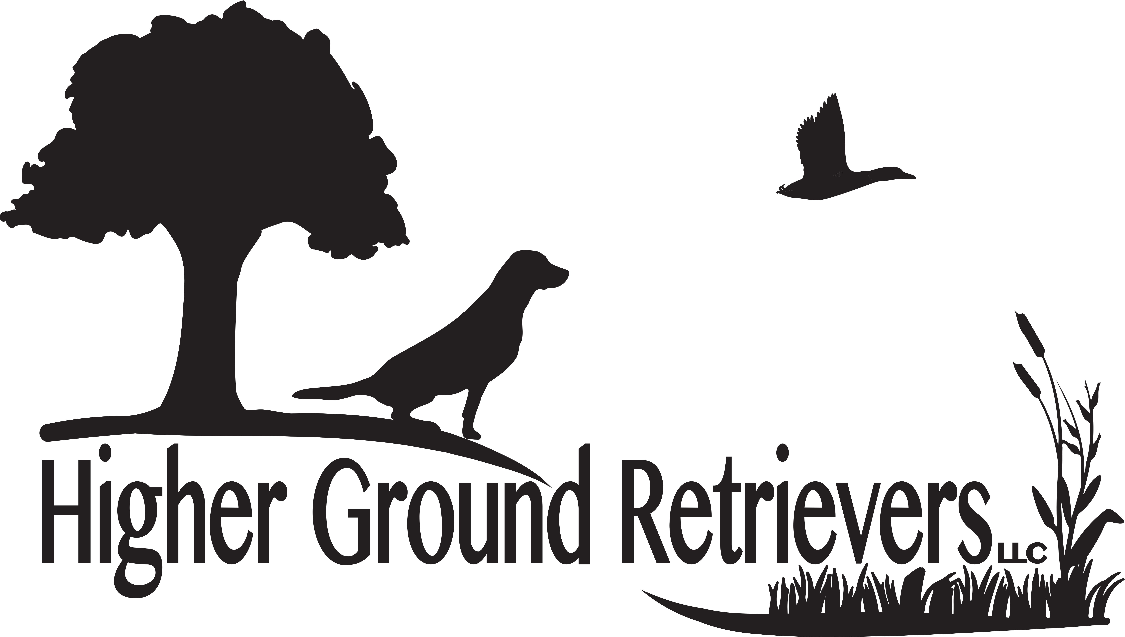

Puppy Contract & Terms of Sale

This is a contract entered into by Higher Ground Retrievers (here and therefore after HGR) and the purchaser.

Higher Ground Retrievers
19853 E. 456 Road
Claremore, OK 74017
918-344-2280
www.highergroundretrievers.com

And Purchaser

Name ___________________________________________________________________________________

Address ________________________________________________________________________________

_________________________________________________________________________________

Phone ___________________________________________________________________________________

E-Mail ___________________________________________________________________________________

HGR agrees to sell the purchaser a Labrador Retriever Puppy.

Bred: ____________________________________________________________________________________

Litter # __________________________________________________________________________________

Sire: ______________________________________________________________________________________

Dam: ______________________________________________________________________________________

Color: ______________________________________________________________________________________

Sex: FEMALE OR MALE (Please circle one)

WHAT IS INCLUDED WITH PUPPY:

- AKC/UKC FULL REGISTRATION
- Copy of Puppy Contact & Genetic Health Guarantee
- 26 Month Genetic Health Guarantee
- Vet exam, and first round of shots
- Shot requirement supplement page
- Dew Claws Removed
- Puppy packet with registration papers

Payment Structure:

Price of Puppy $____________________________________________________

Less (Non Refundable) Deposit $__________________________________ Check acceptable

Balance Due at time of puppy pick up $___________________________ CASH OR CASHIER CHECK ONLY

ALL RETURNED CHECK WILL ASCESS A $35.00 FEE ADDED

DEPOSIT

Deposits are required to hold specific gender and color (multi color litter such as Black & yellow, Black & Chocolate) of a puppy in a specific litter.

DEPOSITS ARE NON REFUNDABLE, UNLESS

- There is not enough male/female puppies for the reservation taken
- Reserved puppy cannot be sold due to illness, or defect.

FINAL PAYMENT :

ALL FINAL PAYMENTS ARE DUE AT TIME OF PICK UP OR 3 DAYS PRIOR TO SHIPPING.
ALL FINAL PAYMENTS ARE CASH OR CASHIERS CHECK ONLY!!!!

ALL PUPPIES WILL BE HEALTHY AT TIME OF PICK UP AND HGR WILL NOT BE REPONSIBLE
FOR ANY INJURIES OR ILLNESS ONCE THE PUPPY LEAVE THE PREMISES OR HAS BEEN SHIPPED.

SIGNATURE OF PURCHASER ___________________________________________________________________________

SHIPPING PUPPIES FROM HIGHER GROUND RETRIEVERS

THIS IS WHAT ONE CAN POSSIBLY EXPECT IN EXPENSES FOR SHIPPING A PUPPY.

$500.00 - $530.00 USING THE AIRLINES OPTION AND ADDIDTIONAL SERVICES.

- $70 - $ 100.00 – ($10.00 a day) for boarding, Puppies have to 8 weeks old to ship in for most service venues. The puppy will receive the same care and continues socialization.

- $95 - $110.00 - Health examination/office visit and Heath certificate including the certificate for acclimation in case of temperatures are below 45 degrees.

- $20 – Microchip for puppy

- $ 40 - $50.00 - Botatella Vaccine ( Kennel cough)

- $40- $80 – for a Airline approved pet crate & Water/food cup.

- $200 - $250 for the American Airlines Cargo Services – pet shipping from Tulsa OK

- $65.00 for transportation to Tulsa International Airport and parking, and to and from vet for health certificates.

- FOR ADDITIONAL INFORMATION YOU CAN VISIT, https:/www.aacargo.com/learn/animals.html

- ALL PAYMENT FOR PUPPY AND SHIPPING WILL BE PAID AT LEAST 3 DAYS PRIOR TO SHIPPING.

If we as a breeder make arrangement to transport the pup, the
cost will be assessed by us. We usually expect you to compensate for fuel, and lodging, and any other necessary expenses such as
health certifications, ect.

